Deakin Universitv

Software Qualitv and Testing
OnTrack Submission

Unit testing using Junit & week 3 learning

Submitted By:
Ayush Shrinivas Indapure
s224880003 2026/03/26 23:06

Tutor:
Zubair Baig

March 26, 2026



Produced by OnTrack


Presented by Ayush Indapure
Student ID : 224880003

SOFTWARE QUALITY AND TESTING

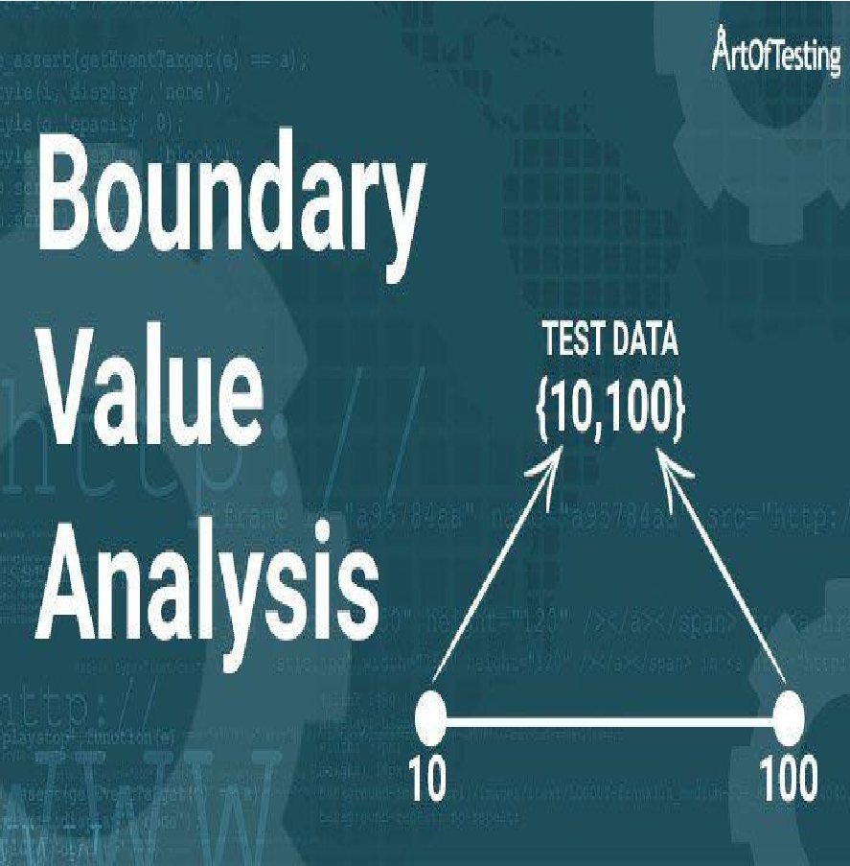
BOUNDARY VALUE ANALYSIS & EQUIVALENCE CLASS TESTING

This week I learned about two important testing strategies
- Boundary Value Analysis (BVA)
- Equivalence Class Testing (ECT)
Both techniques help testers design efficient test
cases without testing every possible input.
Instead of testing thousands of inputs, we focus on critical input ranges and edge cases.
These strategies are commonly used in real-world software systems where inputs have specific limits or constraints.



BOUNDARY VALUE ANALYSIS

BVA
(Boundary Value Analysis)

BOUNDARY VALUE ANALYSIS FOCUSES ON TESTING VALUES AT THE EDGES OF INPUT RANGES.

BOUNDARY VALUE ANALYSIS

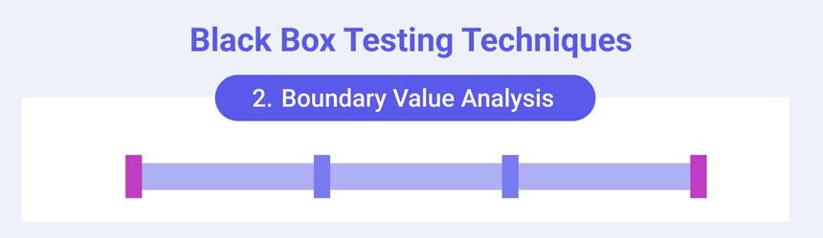
Boundary Value Analysis (BVA) is a software testing technique that basically focuses on testing input values at the edges of defined ranges, as defects are most likely to occur at these boundaries rather than in the middle. .
This black-box testing method is based on the observation that errors frequently happen when values are just below, at, or just above the valid limits of an equivalence partition. Testers design test cases to cover the minimum, just above minimum, nominal, just below maximum, and maximum values of a range, often testing both valid and invalid partitions.



REAL EXAMPLE I9VE
SEEN (DSA CONTEXT)

EXAMPLE THROUGH DATA STRUCTURES AND ALGORITHMS
While practicing Data Structures and Algorithms, I noticed boundary problems often appear in array indexing. Example:
int[] arr = new int[10];

Valid indexes are:

0 – 6

If a program tries to access:

arr[10]

it causes an ArrayIndexOutOfBoundsException. So the boundary values are:
0, 1, 8, 6

Testing these helps ensure the algorithm handles edge cases correctly.

This is very similar to Boundary Value Analysis used in software testing.

EQUIVALENCE CLASS TESTING(ECT)
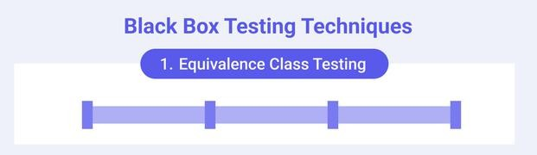
Equivalence Class Testing divides input data intogroups (classes) where the program shouldbehave the same. Instead of testing every possibleinput, we select one representative value fromeach class.
This black-box testing method is based on theobservation that
errors frequently happen whenvalues are just below, at, or just above the validlimits of an equivalence partition. Testers designtest cases to cover the minimum, just aboveminimum, nominal, just below maximum, andmaximum values of a range, often testing bothvalid and invalid partitions.

EXAMPLE THROUGH DATA STRUCTURES AND ALGORITHMS
A common real-world example is password validation. Suppose a system requires:
Password length: 8 3 16 characters

Equivalence classes would be:
Valid class
8316 characters

Invalid classes
< 8 characters
> 16 characters

Instead of testing every possible length, testers choose representative values like:
7, 8, 12, 16, 17

HOW THESE METHODS ARE USED IN REAL SOFTWARE
Both testing techniques are widely used in real systems:
Examples include:
- Banking systems (transaction limits)
  - E-commerce websites (quantity limits)
  - Input validation in web forms
  - Date calculators and scheduling systems
  - API request parameter validation
By focusing on boundaries and input groups, testers can reduce the number of tests while still achieving high
coverage.

REFLECTION

Both testing techniques are widely used in real systems:
Examples include:
- Banking systems (transaction limits)
  - E-commerce websites (quantity limits)
  - Input validation in web forms
  - Date calculators and scheduling systems
  - API request parameter validation
By focusing on boundaries and input groups, testers can reduce the number of tests while still achieving high
coverage.

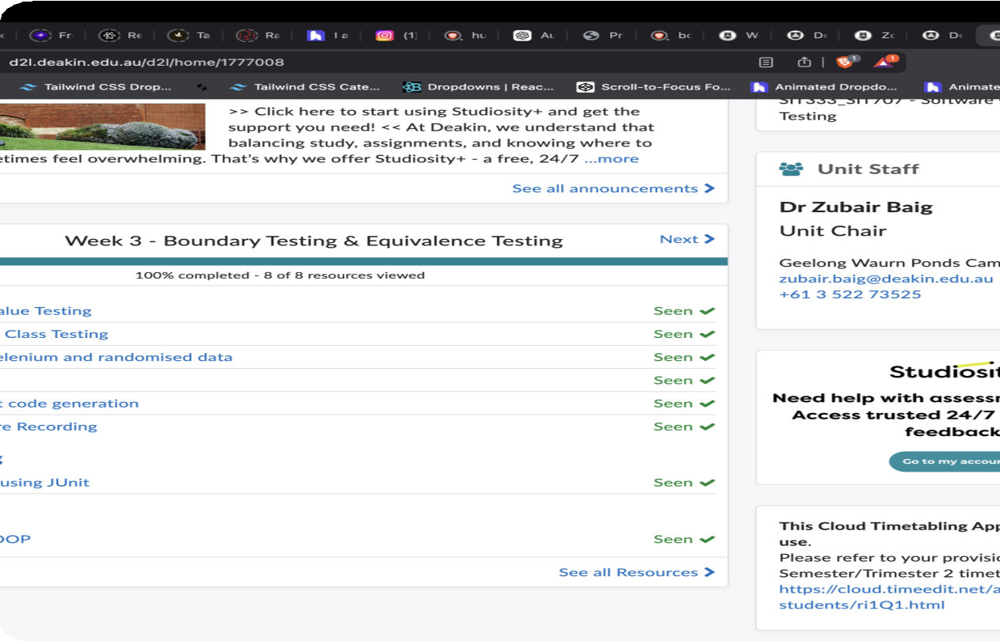
EVIDENCE OF LEARNING ACTIVITY
During the active learning session I explored:
- Boundary testing for a date calculator program
  - Using JUnit test cases to validate date
boundaries
  - Testing edge cases such as:
- Start of month
- End of month
- Leap year conditions

Thank You!

SIT707 3 Softwaíe Quality and Testing
Student Name : Ayush Indapure Student ID : 224880003

Introduction :

In this task, I bacisally implemented unit testing for the dateUtil class using the JUnit testing framework.

The purpose of this task was to verify that the date calculation functions work correctly for different scenarios such as normal days, month boundaries, and leap years.
Unit testing helps ensure that individual components of a program behave as expected. By creating automated test cases, developers can quickly verify whether the program still works correctly after making changes.
In this task, I created multiple test cases to check both the
next date and previous date functionality of the program.

Part A 3 Test Case Design
While designing the test cases, I tried to include scenarios that represent real-world situations where date calculations might cause errors.
For example, firstly changed the name to Ayush Indapure and student ID to 224880003 when the date is at the end of a month, the next date should move to the first day of the next month. Similarly, leap years must be handled correctly because February has 29 days instead of 28.
Some of the important scenarios tested in this assignment include:

Normal Date Increment

A standard date such as 15 March 2023 should correctly increment to
16 March 2023.

Month Boundary

When the date reaches the last day of a month such as 31 January, the next date should become 1 February.
Leap Year Case

In leap years, February has 29 days. Therefore a date like 28 February 2024 should increment to 29 February 2024.
Previous Date Cases

The program should also correctly calculate the previous date. For example:
- 1 March 2023 ³ 28 February 2023
- 1 January 2023 ³ 31 December 2022

These cases help verify that the program correctly handles transitions between months and years.

Part B 3 JUnit Implementation
JUnit was initially used to automate the testing process for the DateUtil class. The tests were written inside the DateUrilTest case.
Each test method uses the @test nnotation and checks whether the expected output matches the actual output returned by the program.
For example, when testing the next date functionality, the program creates a date object and verifies whether the nextDate() method returns the correct value.
The assertFunction() function from JUnit was used to compare the expected result with the actual result returned by the program.
This approach allows the tests to run automatically and quickly detect any issues in the date calculation logic

Test Execution
All test cases were executed using JUnit in Visual Studio Code. After running the tests, the testing panel showed that all test cases executed successfully without any failures.
The results indicated that the program correctly handles: ï Normal date transitions
- Month boundary transitions
- Leap year scenarios
- Previous date calculations

JUnit Test Results
The JUnit test execution confirmed that all test cases passed successfully.
Example result:

Tests run: 14
Failures: 0
Errors: 0
Skipped: 0

This confirms that the DateUtil program behaves correctly for the tested scenarios.
.

